My Navy Years
by
Fred Harder

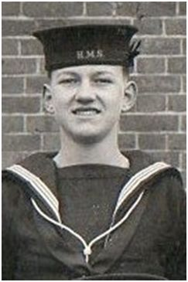

My Navy Years 1.
As a Boy I always wanted to be either a Farmer or a sailor, but living in Southampton it had to be a sailor, at a young age when Mum took us to the seaside (Weston) or Dad took me further afield to Bexhill or other places in his work I would hold my hands as if they were binoculars and look out to sea and imagine that I was at sea with no land in sight.
After Leaving school I had a couple of jobs which only lasted a short time as I still wanted to go to sea, so after trying to get into the Merchant Navy with no luck (to this day I am pleased that I didn’t) I decided to try for the Royal Navy, there was a naval recruiting office in Orchard Place opposite the dockyard gate in Southampton, I cycled down there and asked if I could Join up, when I told them my age they said I would have to join as a Boy, I was told to attend an interview but I must first have my parents written consent to join , Dad was not very pleased for me to join the navy, but Mum talked him into signing the papers, so I duly attended the interview with my signed chitty in my hand, there was a basic test of arithmetic and reading plus a little basic test on common sense things like they gave you a picture of a handsaw and underneath was a drawing of a wall brick, iron, wood a few other things and asked what you would use the saw to cut, I’m not the brightest of people, but I passed with flying colours and was told to attend again to sign up and not to bring anything with me .
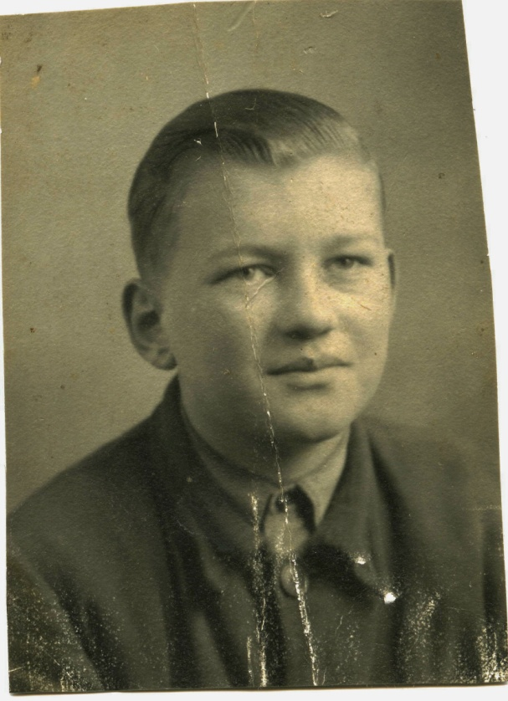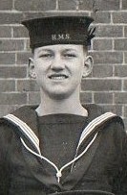
The day came for me to leave home 7th March 1950, the normal goodbyes, Mum waved to me going up the street to catch the tram into town, when I arrived at the recruiting office there were about 15 other boys there, to my surprise one was my cousin from Honeysuckle road, and another was Sandy Martin a pal who lived just up the top of the road from me and who attended Sea cadets at the same time as me. We were all taken by Royal Navy Lorry to the Central Station where we caught a train to Gosport,(this was before all the train were cut
2.

and they still went to Gosport) at Gosport we were met by another R.N. lorry which took us through the town to H.M.S. St Vincent. A very imposing establishment,
We were driven through a big archway which opened onto an extremely large parade ground surrounded by high walls with at one end tall red buildings in front of which was a very tall mast.
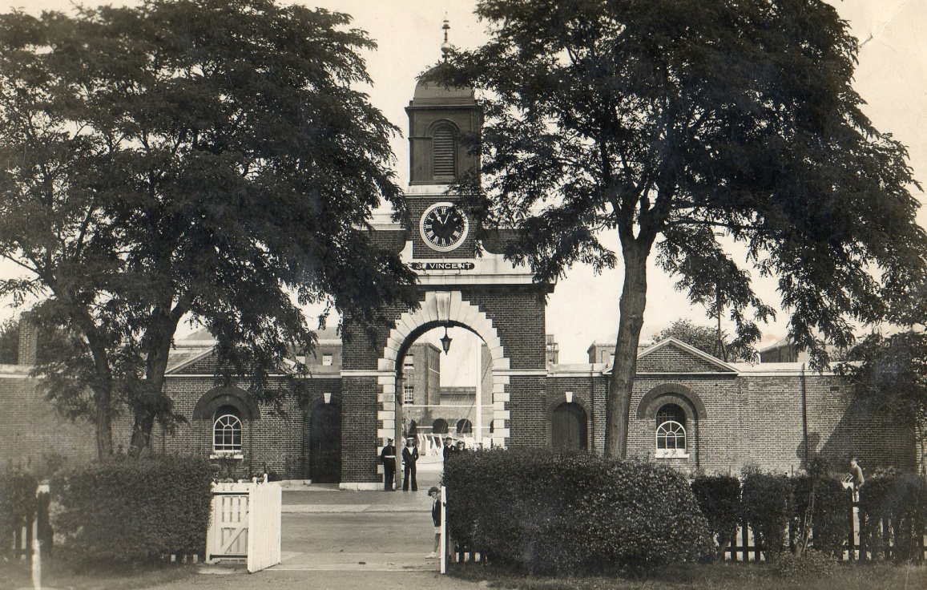
H.M.S. St Vincent main gate
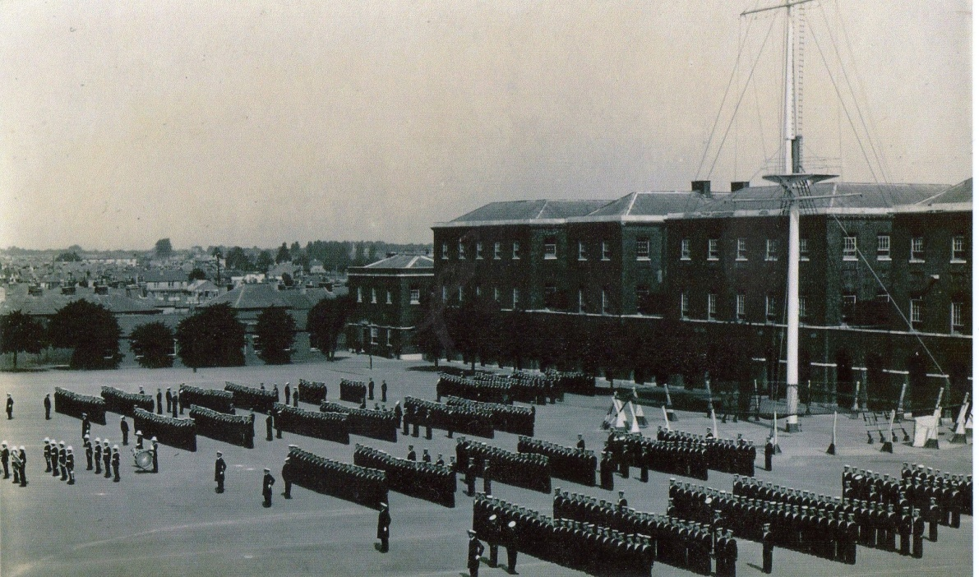
St Vincent Parade ground and mast. (Very old Photo) officers
in dress coats but otherwise nothing has changed

3.

we were driven across the parade ground to the New Entry annex where we met up with other boys who had come from all over the country to join up. I was now in the Navy as Boy Seaman 2nd Class Frederick HARDER official number JX 882865 but it would still be some time before I went to sea. We were then split up into messes (Dorms) and into classes I was placed into New entry division, HOOD class. We were then taken to the clothing store and issued with our uniforms. First we were given a large kit bag, followed by two complete uniforms, 1 for best and 1 for working,(No Number 8’s uniform, we were issued with overalls) then two of each of everything - blue collars, a black silk square, lanyards white fronts, vests, underpants socks stockings two hats one black one white, plus a metal hat box to keep them in so that they would not get out of shape, boots, slippers pumps and football boots, sports wear shorts long sleeved jumpers then there was a blue kind of bag which was called a “house wife” which contained everything needed to sow and repair your kit from needle and cotton to buttons, black and white tape and wool (To darn your socks) two boot brushes with black and brown polish and a clothes brush, blue gloves and a black woollen scarf that could be turned into a hat, green military belt and gaiters, we were then issued a money belt then onto a counter where they gave you two towels, a flannel, a bar of soap for washing your clothes and a bar of ordinary soap, tooth brush and paste (a pink powder in a little tin, no tubes in those days) a shaving brush, shaving soap and a cut throat razor, (no safety razors) a comb and brush and a small attaché case, by this time the kit bag was getting quite full (and Heavy) but they had not finished there was a heavy navy coat of thick wool and an oilskin (for wet weather) then onto bedding, 2 thick rough wool blankets and a couple of pillow cases and a Royal Navy counterpane (no sheets or pyjamas it would be a few years before they supplied them, you slept under blankets in your underwear) 2 mattress covers There was no Hammock or clues (The thin rope strands at the end of the hammock to tie it to the sky hooks) or lashings, you got those when you were getting ready to go to sea. Finally you were given a seamanship manual, a bible and a large military respirator (gas mask which went over your head and had a long pipe to a filter which was contained in a canvas shoulder bag ) 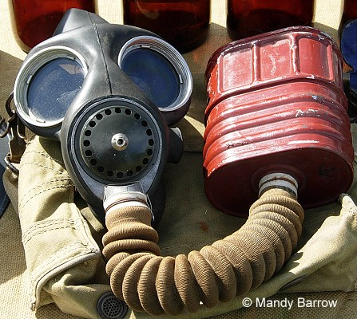 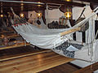

4.
With all our kit and our kitbag over our shoulders we were ushered into our mess and allocated a bed and locker, we dumped our kit onto our beds and were then made to strip and place all our civilian clothes and any possessions that we had with us into a large brown box and make it into a parcel, we had to brown tape it up and put our home address on and send it home, we were all in the noddy and you could tell the kids that were not used to being that way in company, we were then taken to the shower room where we had to shower and then go to the barbers for a haircut.
Back in the mess we were shown how to dress in our nice new uniforms, I and a couple of other lads who had been in the Sea Cadets knew how to dress so when we were fully dressed helped those that were getting in a muddle, as it can be quite a job getting all your uniform on in the correct way.
We were then taken to the mess hall and given a meal afterwards we were given a lecture by the OIC. When that was finished we returned to our mess and shown how to made up our beds in the naval style we then turned in for a well earned sleep, during the night you could hear a few of the younger kids crying as it was their first time away from their Mothers and home so they were home sick, the next morning we were woken by the blast of a bugle call and our instructor petty officer shouting “wakey!, wakey! rise and shine the mornings fine out you get” he then turned over the beds of the boys who were slow in getting out, he then proceeded to show us how we should make our beds up in the Naval style, everything had to be taken off the bed, the counterpane was then placed over the mattress and tucked in tight, the blankets had to be folded in a particular way so that there was four folds instead of the normal two then the pillows on top. Many years Later when we were issued pyjamas they would be rolled up and placed in front of the blanket and pillows.
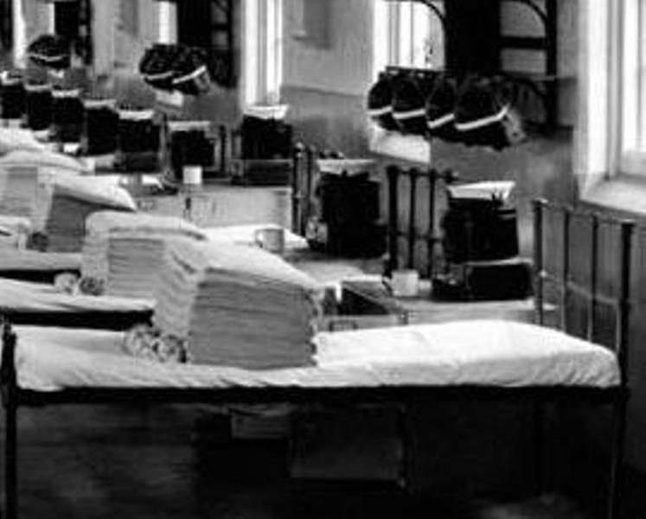

5.

When we had mastered the blanket folding, we had our breakfast in the mess hall, we were kept away from the old salts who had been there over the six week training period, then we were taken to be issued with an Identity disc (Fire proof so that if the worse came to the worse and we were burnt, you could be identified) to be placed around our neck never too be removed.
We were then taken into a room with benches and a sailor gave us a strip of wood and some little blocks of wood with the letters of our name in type which was made up into a wooden block with your name in reverse) 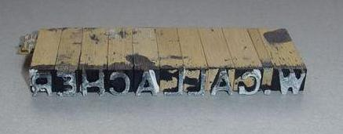back in the mess we were given two pieces of surge on which was impregnated with black or white paint then with our name type and the paint, we had to mark every part of our kit with our name, while our boots, shoes, football boots, brushes and cap box were all stamped with our names on. Our kitbags were marked in a similar way but with bigger letters, after they had all been marked we had to take our kitbag with our name and official number on to have our I.D. photos taken to be placed into our Pay book (This gave all your details Name D of B, height colour of eyes blood group etc)
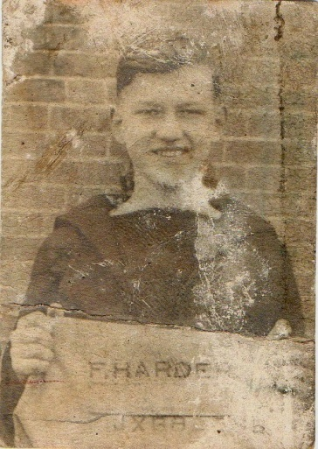 nice new haircut and uniform.

We were then issued with a number of scans of Red “ANCHOR” silks, which we had to use to sew with chain stitch every item of our clothing with our name. Most of it had to be done in our own time when not buffing up our boots, washing, ironing and swatting up. Every item when complete had to be shown to the instructor, if he did not like it and it did not look tidy you had to undo it and re sow it, I was very glad that I never had any other initials than F.
6.
Some kids had lots of initials and long names, some were lucky if they were a Mc something or other and it was long all they had to do was the Mc and the first letter of their name, some with short names finished first and for a little fee would sow an “X” number of letters for you.
Here in St Vincent we did our first six weeks basic training.. learning to dress, wash clothing clean our brass buttons Blanco our gaiters marching doing all types of formations on the march with or without rifles, plus learn about seamanship tying knots, box the compass, learn all about the parts of a ship, basic navigation and a hell of a lot more, I was lucky having been a Sea Cadet knew how to put my uniform on etc, One day we were all taken to the sickbay to have our jabs, time flew and before long we were allowed out on a Sunday afternoon to walk around Gosport. One day we were all told to dress in our number one dress suit as we were to have our photos taken.
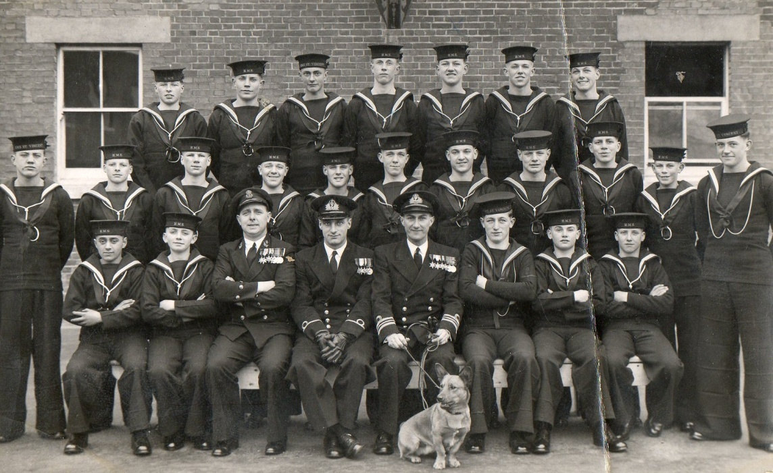
Hood Class, some classmates I went to Ganges with and some I met all The “M” over the nose.
over the world,

7.
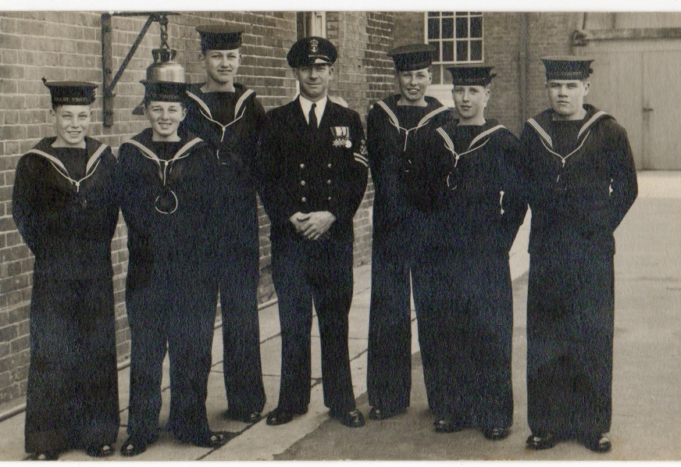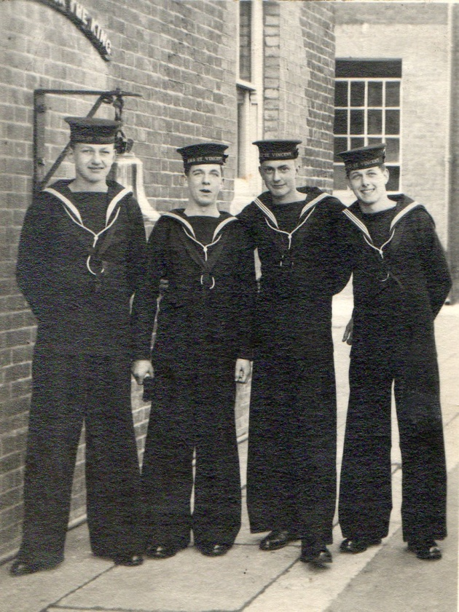
Fred with some of his mates. Fred standing alongside his cousin.
My cousin I Think made it through his course but I never met up with him, while Sandy Martin the friend I signed on with never lasted the six week course. We had a lot of sport activities, the first being that we were all lined up by size, two lines red and blue each pair had to enter the boxing ring and beat hell out of each other for 3 minutes, the person judged to have won (Me) had his hand lifted above his head and the next pair took over. We had to participate in all the games, Hockey, Rugby, football cross country running etc. Also we had to take swimming lessons and at the end had to do a test to get our swimming proficiency certificate, this entailed being dressed in white duck suit made of light canvas and having to swim a couple of lengths of the bath then duck dive to the bottom in the deep end and recover a heavy object and then swim on your back with this weight on your chest to the side and give it to the instructor, I and a few other that could swim passed the test the first time round and had our pay book noted to the effect that we had successfully passed the test, but there were quite a few non swimmers who had to take extra lessons in the evenings or early mornings.
On One weekend the New Entry Division was opened up to visitors and our parents were invited to visit the establishment, My Mum and Dad came down and watched us doing our parade marching and then they had a looked around our accommodation and classrooms, then had tea with sticky buns before being driven to the station, I think that they were very proud of how I was getting on.

8.
As our basic training as Boy seamen 2nd class progressed, we were taken on a visit to H.M.S. Victory. Which was every boys dream, as we marched through the dockyard arms swinging to our shoulders, being watched by all the salted sailors from all the different ships decks, there were a great many warships tied up alongside the jetties, there were cruisers, destroyers, frigates submarines and minesweepers, while the biggest one was the battleship H.M.S. King George V, which to us was massive.
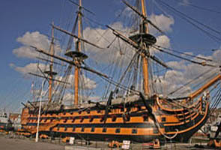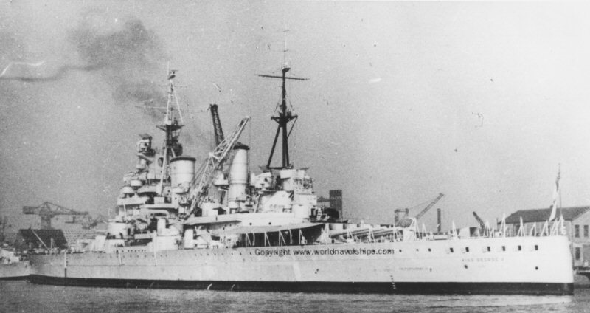
H.M.S. Victory Portsmouth dockyard H.M.S. King George V

As our training course in H.M.S. St Vincent was coming to an end and our exams and tests had been passed not everyone made it, We were told that as boys we could become Seamen and at a later date choose the branch/profession that we wished to go into, or become boy communicators and after a basic training in HMS GANGES could become communicators and specialise as a Radio Operator Or Visual as a signalman, a number of us volunteered and were chosen to do a Morse aptitude test to become a communicator. I was one of the chosen ones, first our Hearing and sight were again tested and had to be 100% then we went into a classroom for the test, the test comprised of having played to us over a radio and being told. That one dit (.)was the letter “E” while one dash (-) was the letter “T” and a few other basic combinations of dits and dashes, these symbols were played to us a number of times and then we had to write down the letters which was then marked by the instructor, I must have been in the top number as I was selected with a few others to be trained as a Communicators either as Signalmen visual flags lights etc call Buntings (Flags were made of bunting) or Radio Telegraphists reading Morse and anything to do with radio communications (In the Navy we were called “Sparkers” as in the early days of radio the valves in the radios sparked to make the required dits and dashes,) having completed our six weeks basic training those selected were transported by lorry to Gosport railway station followed by another lorry with our kit bags to catch the train to London, in London Waterloo we were met by military police with another lorry to take us across London to catch another train for Ipswich, where we were met by a Naval Bus who transported us to H.M.S. Ganges.
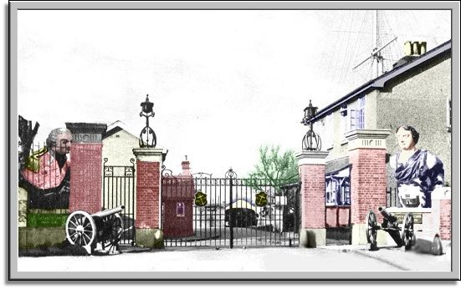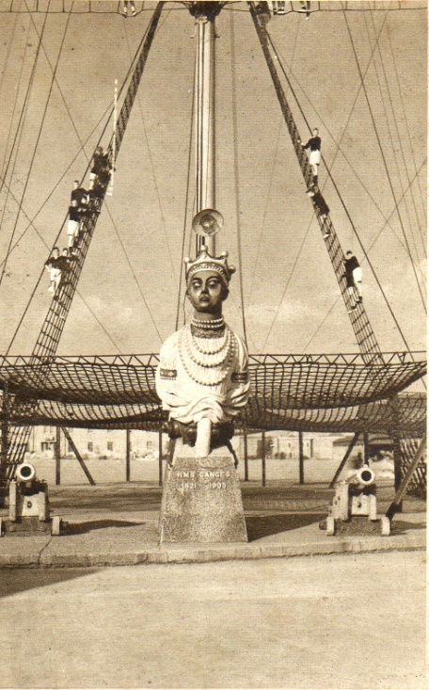
H.M.S. Ganges Shotley Main Gate Ganges figure head and Mast
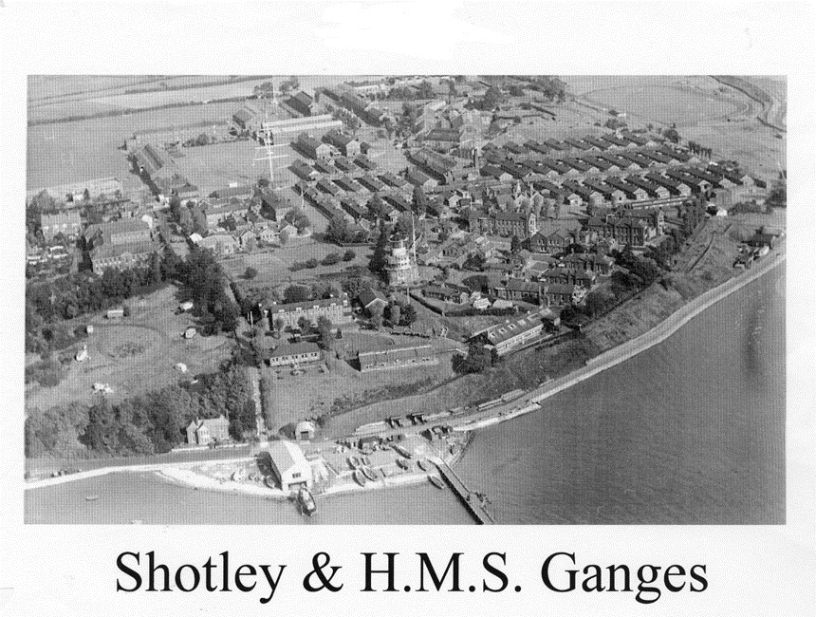
I was assigned to and joined Grenville division (All the divisions were named after famous Admirals) which was situated in a very long covered way with messes on either side I was allocated class 222. The Messes consisted of a single floored building which you entered from the long covered road on entry there were two little rooms one was the wash room, the other the dhobi room where you did you washing, along the passage it opened up to a long dormitory the first patch was a large square of wooden tilled flooring, white from being scrubbed so many times, this area was the dining area and contained 4 tables with benches, plus a locker to stow your cups etc, there were also the utensils e.g. very large teapot, “Fannies” for soup, stews porrage etc. “All highly polished, by us of course ” used to go to the galley to collect your victuals and then there was the highly polished wooden floor area with beds either side with a locker alongside each bed where you kept all your clothing clean neat tidy and tied up in rolls..
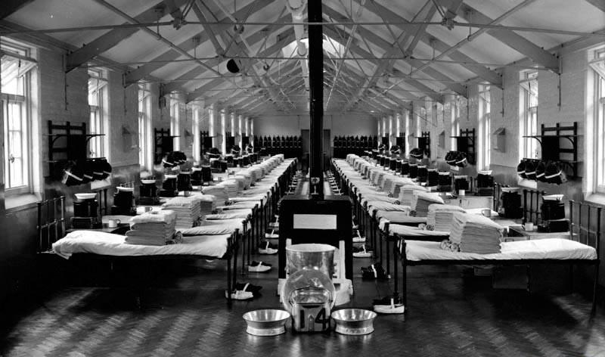
We were issued our bedding and given a bed and locker to stow our gear away, we empties our kit bags, the kit bags went under the mattress with our best bellbottom trousers folded in the regulation manor with 7 creases across while turned inside out on top of the kitbag to keep the creases in, some people smeared pussers (NAVAL ISSUE) soap on the creases to keep them in, it worked, but the soap rotted the material. By the time all this was accomplished, it was time for our evening meal, a couple of the lads were detailed off to be the cooks of the mess and go to the galley and collect the evening meal, the tea was made in a big “Fanny” by placing a couple of hands full of tea, sugar and carnation milk and taking to the galley for hot water. We were all issued with a plate, mug and knife and fork. We had to mark the plate and mug with our initials this was done by pouring a drop of vinegar on the item and then with a piece of aluminium scrape out the initials, it works. after our meal we had to wash up and stow all the gear.
On our arrival we had been introduced to our instructors I think mine was Acting Petty officer Hammond, who was still in the same uniform as us, who fell us into a squad and we had to march around the establishment having points of interest shown to us to remember.
After some more basic training e.g. learn to read the Morse code and progress in speed, at the same time learnt how to type we started with the middle line on the typewriter with the letters ‘a’’s’ then ‘s’’a’s on our left hand fingers and thumb then added the symbols and letter with our right hand ‘;’’l’ then ‘ l’ ‘;’s on the middle line on the keyboard and progressed to all the keys on the keypad we were to be touch typists, so we progressed to having all the keys covered with little black caps so you did not know which keys were which, we then progressed further and had to read the Morse code while typing the letters and figures. At the same time we went to school progressing our maths English etc., also we carried on with our seamanship and rope work knots, splices and whipping, navigation, rule of the road, reading the 24 hour clock, after a time
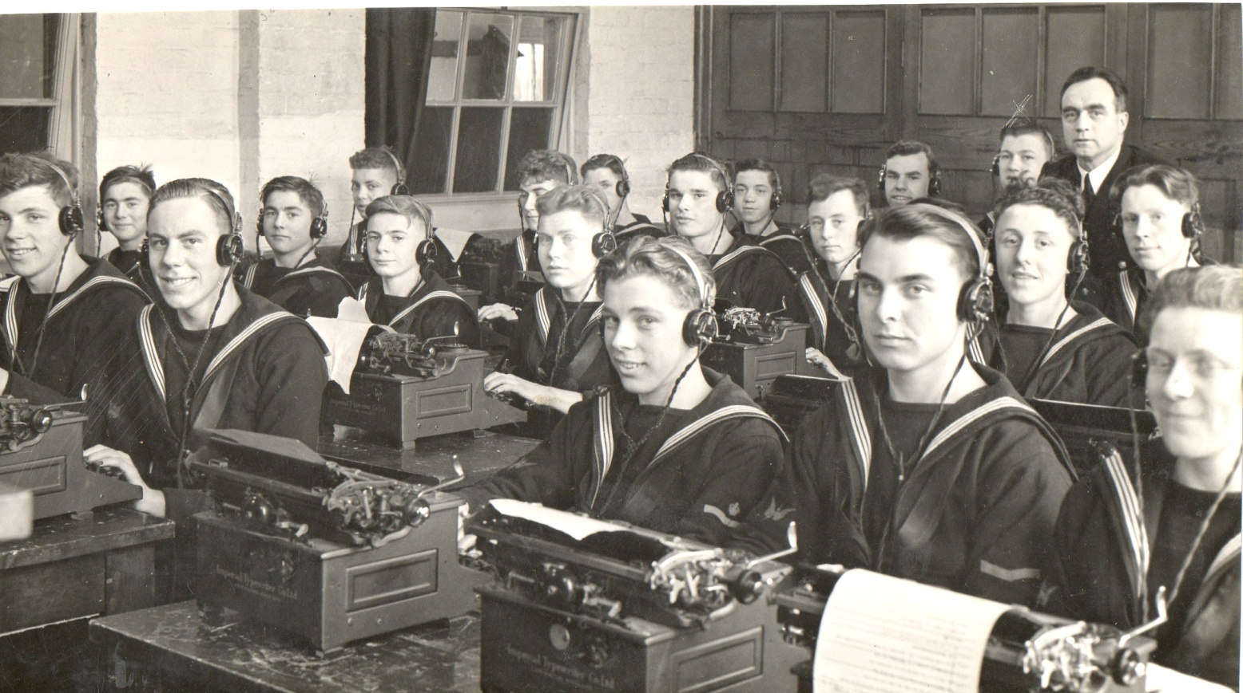
233 Class touch typing and reading Morse on Old imperial typewriters

we sat further test to see who would become Signalmen (Flags, flashing light , semaphore and ships manoeuvres ) or Telegraphists ( Morse code, ciphers, codes and radio equipment ) I was selected to be in the telegraph’s stream and made up to Boy Telegraphist 2nd Class., My training in Ganges took 15 months having been back classed for a few weeks into 233 class, never could get right the S’s 3(dits) ... and H’s 4(dits) .... Especially when the speed was upped. But I was O.K. on the 5’s which was 5(dits) ..... Though. After a time we had to sit an examination and on passing were issued our branch badges, cross flags for Signalmen (Buntings or Bunce) and flying lightening with wings for the Telegraphists (Sparkers). Which we had to sow onto our uniforms, gold badge for our best uniform (No 1’s) and red ones for our No 2’s and blue and white ones for our working uniform.
Every week a different class had to do guard duty, that is be ahead of the parade ground and march off etc.
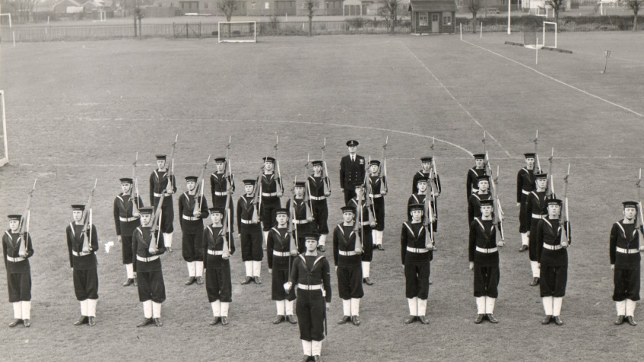
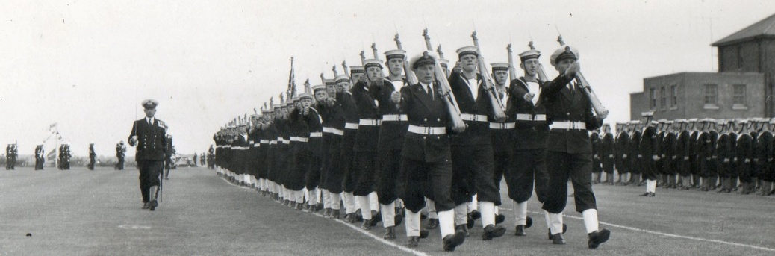
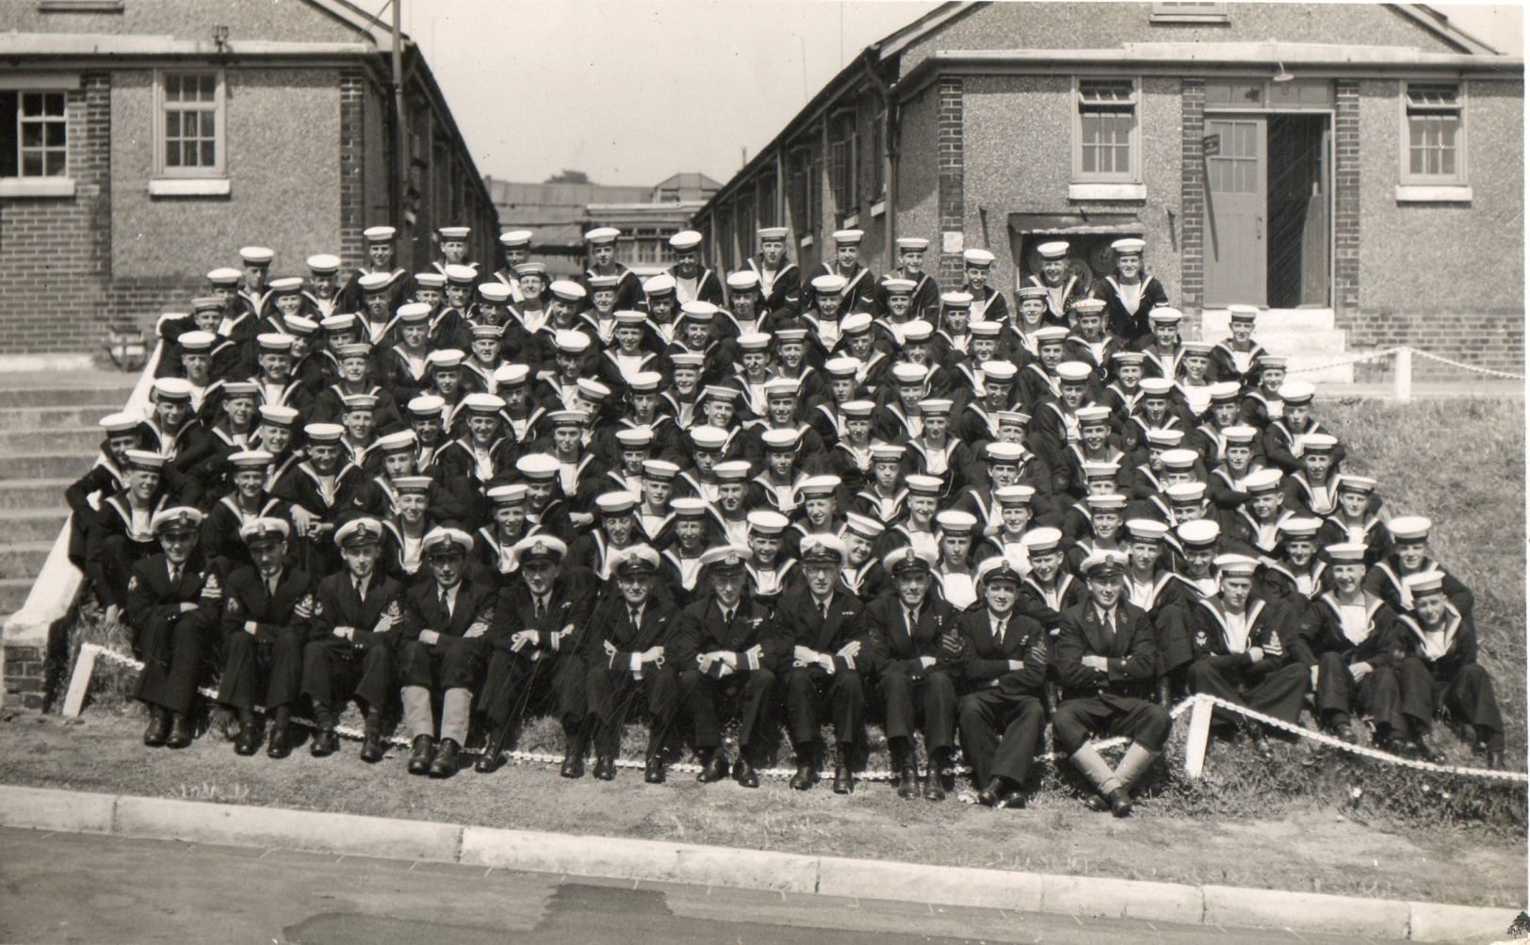
Grenville Division 1950/1
While in Ganges, I played water polo for the division and was in the Field Gun’s crew and we won medals for the two highest honours, the overall winners and the fastest time.
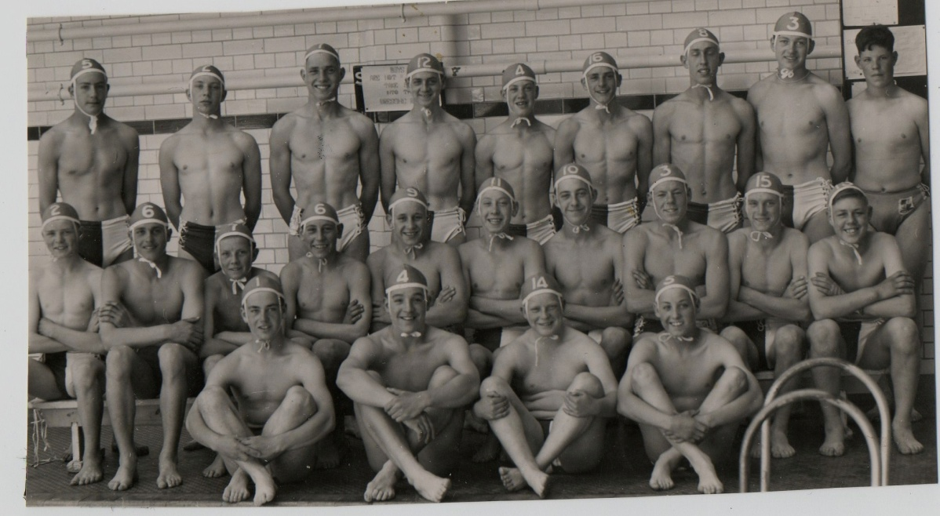
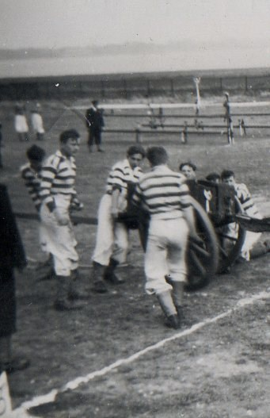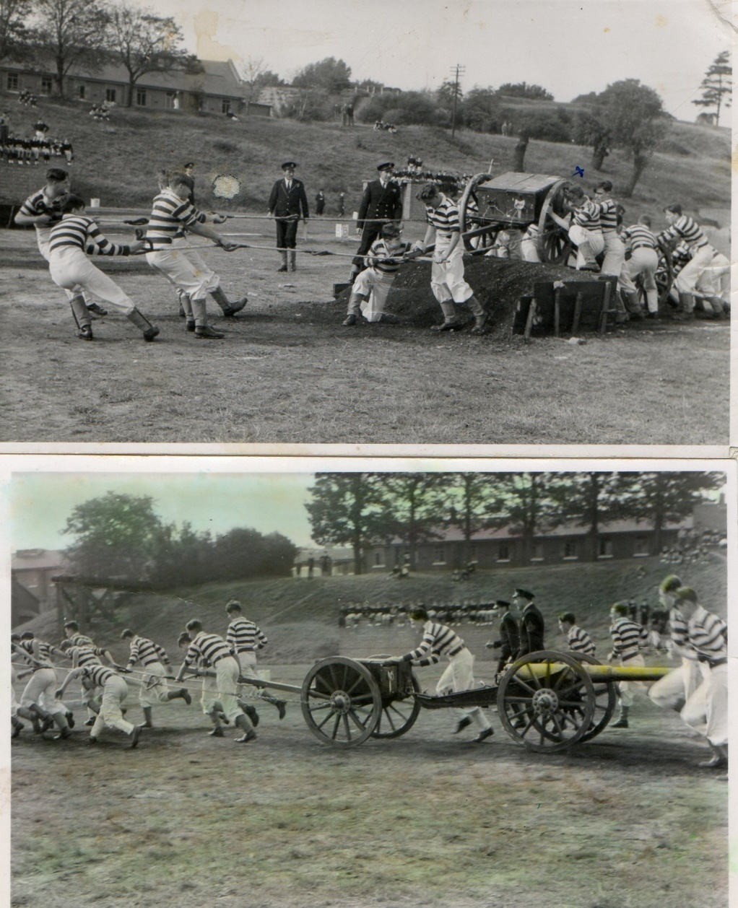
I was also in the Kings Birthday review guard.
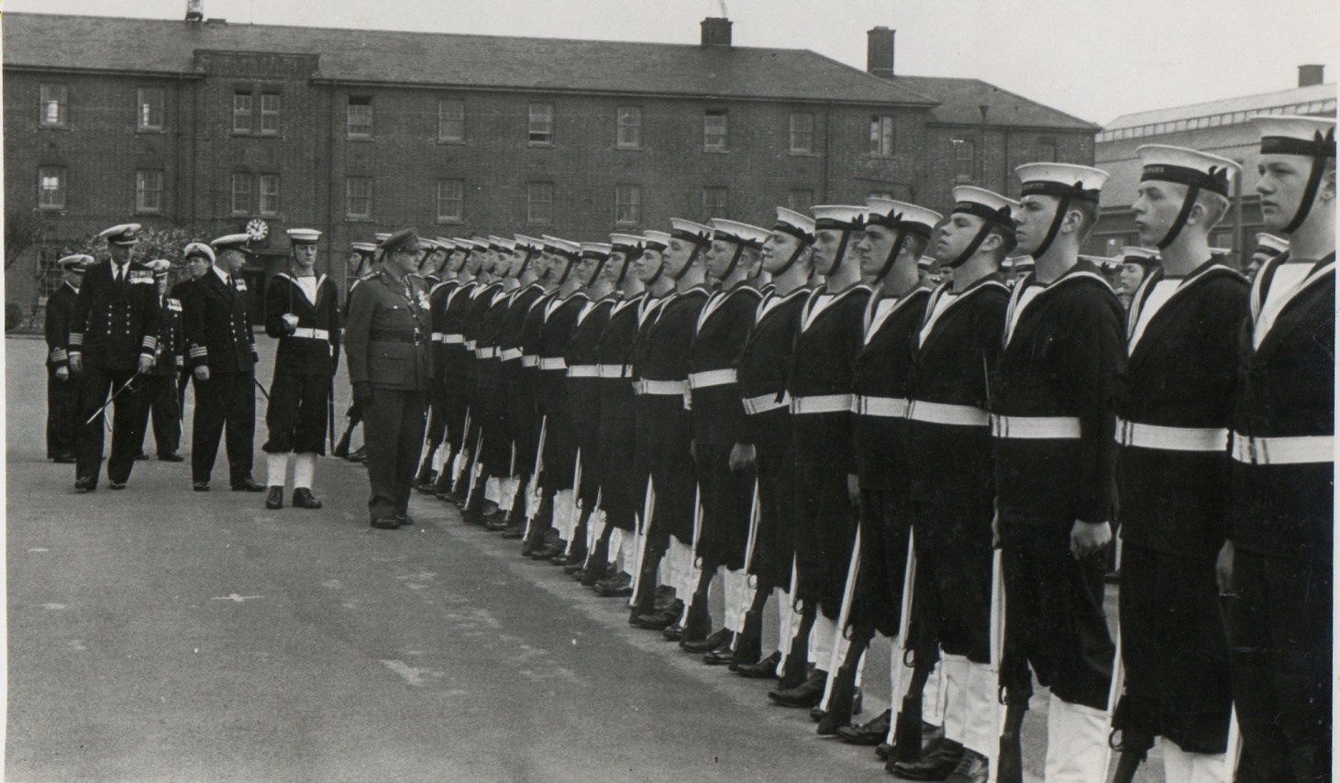
Wednesday afternoon was our half day off it is called a Make and Mend day (To repair or make things to your kit). But most of all we had to take part in sports, I had to play Football, hockey and rugby cross country running and a few other games, The G.I. (Gunnery Instructor) wanted me to take up Boxing,

The reason being that he thought I had it in me to be a boxer, as one day in the mess I sat down at the table with a cup of tea and a biscuit or something, and this bloke across from me who fancied himself as a boxer broken nose etc, took the cup and said “This is mine” I grabbed it back and said “Oh no it isn’t it’s mine” he pulled it towards himself both of us having hold of the cup at the time and said “Mine” this happened a few time backwards and forwards , then when he did it again I let it go and the Hot tea went all over him. He got up and threw a punch, I retaliated then he put his head down and started flaying his arms all over the place, I put my hand over his head to keep him at bay, when he lifted his head, I hit him once and he fell backwards over the bench, looking up there was the G.I. watching us, We were both put in the RATTLE,(Placed on a charge for fighting) and brought before the Officer of the day on the quarterdeck, and we were both given punishment about three or four days No 7’s(I think) having to get up early do cleaning, report every so often, then in the evening after evening instructions run(Double)around the parade ground with our rifle’s over our heads, we were never along, there was always quite a few doing “Jankers” (Punishment). Anyway I could not box as I had what they thought was a weak stomach, one punch and I was knackered, I did as every new recruit had to do in St Vincent, that is ”box in the mill”, as part of your training, one class is given blue ribbons to tie around their waist the other class is given Red.
Everyone has to go in the ring in turn and box like hell (Blood and snot) against your opponent for 3 minutes, the ref then says which one had won, it was then the turn of the next two to enter the ring. (I did win my bout)
Life in Ganges was quite hectic, reveille bugle call would go about 6.30 followed by the same music every day one was “If you roll a silver dollar down upon the ground it will roll roll roll” must have been the current number 1. It was then a mad rush to wash normally in cold water. If you were boat party, you had to get up earlier and go sailing or rowing on the river, come rain, snow or shine.
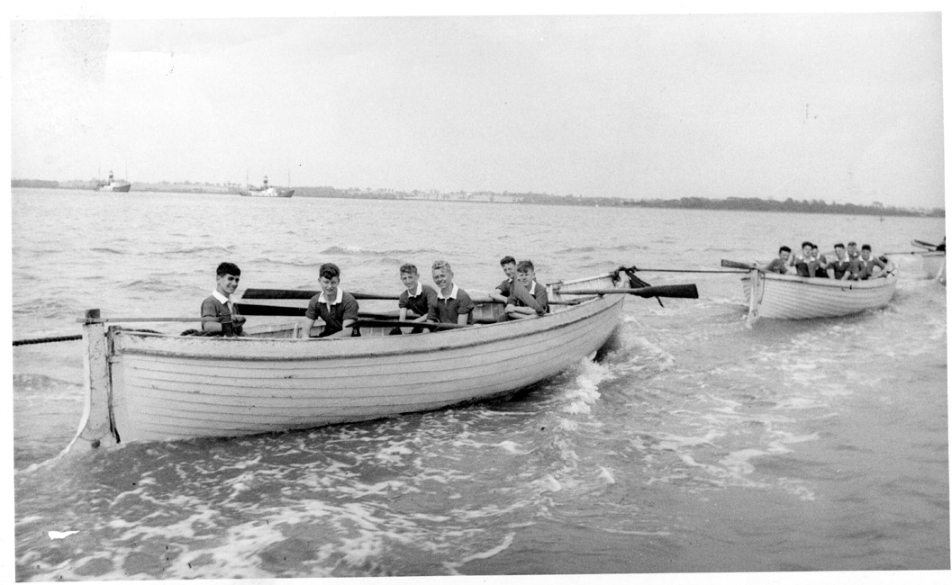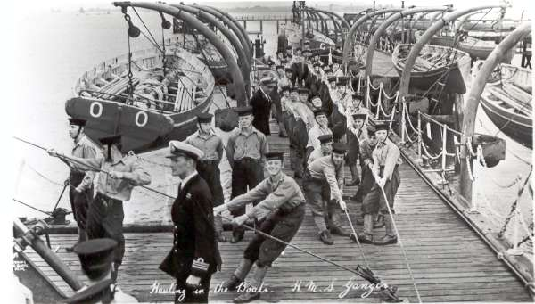
(Some of the older boys shaved, so we were all issued with shaving gear and Cut throat razors, I gave mine to my Dad) make up your bedding - all the blankets and sheets all folded in regimental style with your name showing. If you were duty cook you had to go up to the galley and collect a fanny of tea, the breakfast and bread and butter. Dish it out in the mess, then afterwards wash and clean the dishes and place them on display in the open shelves.
You Normally would then Muster outside your mess and report to the duty Officer that everything was correct no boys gone missing and then be double marched away to instruction, sometimes everyone would fall in on the parade ground for prayers etc.
Once a week we would have to do our washing in the wash house, We would all have to strip and was allocated a large sink and soap to do our washing, most times the water would be cold and they would swish the water all over the place, first the whites, white fronts, vests, hankies and underpants, the underpants were the worst to wash (Scrub) as they were the long ones that came to your knees, no Y fronts in those days, and because all our blue surge uniforms were new, when you sweated, the dye would transfer to your underpants and under your armpits on the white fronts, you would scrub them until you thought they were clean, then take them to the Instructor who would inspect and if they were not clean enough would dip them in the cold water and hit you with them, so you had to go back and rewash. Before putting them in the dryer, the following photo must have been taken some time ago as we never had canvas trousers.(Only for our swimming test).

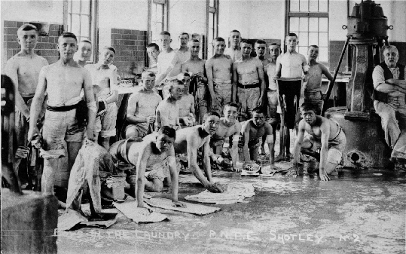
This is an old photo, I expect they have their pants on because of the photo.

Every so often, we would have to take tests, or exams in reading Morse, by pencil and on typewriter, touch typing, sending morse on a key, reading and sending flashing lights, know the colours of all flags and their Naval and international meaning, the basic formations of ships, read semaphore, how to use codes and code books, at the same time there was our educational test in maths, English Magnetism and electrics, plus our marching and arms drills and of course our Kit musters. At the end of one of the test I was made up from Boy Telegraphist to Ordinary Telegraphist, giving me a little more pay,
Three times a year we would be given two weeks leave, On leave mornings we would be up very early about 4ish, the duty cook would go to the galley and collect a fanny of KIE which was a very thick Coco, and a packet of hard (Very Hard) ships biscuits for each of us, then we would have to strip and have a shower in the very cold shower room with even colder water. As you can guess we tried not to stay there too long, but the instructors watched us so we had to show willing. It was then back to the mess to change into our best uniforms, then fall in (Muster) on the parade ground to have our Pay, our victualing allowance (To give to mum for our keep for the 2 weeks) our ration coupons, as some things were still rationed, and our train warrant, when that was completed we all had to muster by destinations, e.g. Waterloo for those going to London and the South. We then got onto buses which took us to Ipswich station, there a mad rush to get to the platform and onto the train, you can just imagine hundred of kid sailor running around shouting laughing and making a noise, I bet they were very glad that it was only three times a year.
Mum was always pleased to see me in my nice uniform, her first job was to get all my clothing and boil them in her boiler until they were shinny white and clean.
At the end of our course, we were all allocated our drafts, if you were going to the Home Fleet you just wore your normal uniform, but if you were going abroad you were issued with your white uniforms, (Again mark all your kit and sow your name in). most of the class were drafted to H.M.S. Forth in Malta which was a submarine base ship, Bill Bailey and Myself were drafted to the Mediterranean Fleet to H.M.S. Mermaid the Leader of the 2nd Frigate squadron based in Malta . We sailed from Liverpool on the troopship “Empress of Australia” and had quite a good time, as the Sgt Major did not know what to do with us sailors. We visited our first foreign port which was Gibraltar. Never having been into bars with saw dust on the floors and all the noise and women around.. it was great, we looked round the shops and bought sweets and chocolate which was still rationed back home. Visited a few bars and had a couple of beers while taking in the atmosphere.
When we disembarked in Malta the Mermaid was still at sea, so we were taken to H.M.S. Ricasoli to await her return, H.M.S. Ricasoli which is/was a large fort at the entrance to Grand Harbour, here we were billeted in the old stables which were built of large sandstone blocks, the ceilings were very high which was great as it kept the place cool. The walls of the parade ground reflected the sun so if you stood on parade for a time it was very exhausting.
. 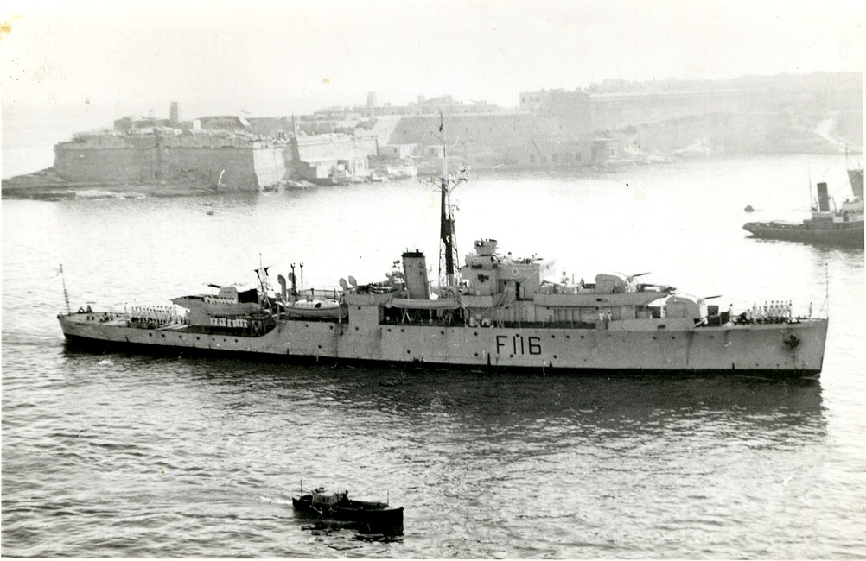
HMS Amethyst of the Yangtze river incident (like Mermaid) in Grand Harbour , with HMS Ricasoli back left ,old fort.
While we waited for the ship to come in, we had to do Morse exercises and general cleaning duties. One thing that I can remember, that at tea time and meals, we had butter which was still rationed at home as was sweets and chocolate, you could go into any shop or vendors tent and get what you wanted, so I made a parcel of sweets to send home to Mum, but before I could fill the parcel (constrained by cash) it came over the BBC that sweet ration had been abolished, so I ate what I had bought, and must have put on a few pounds.
We were kept busy while we waited for the Mermaid, we would spend some time in cleaning ship then we would spend more time in the classroom doing Morse and typing tests. In the evening we would either go out for a drink, or walk along the battlement.
Finally the day came and we watched Mermaid our ship sail past the entrance to Grand harbour and enter Sliema creek which was her normal anchorage tied up between two buoys alongside (some of the time) to a couple of other Frigates or Destroyers. That is when we had a navy.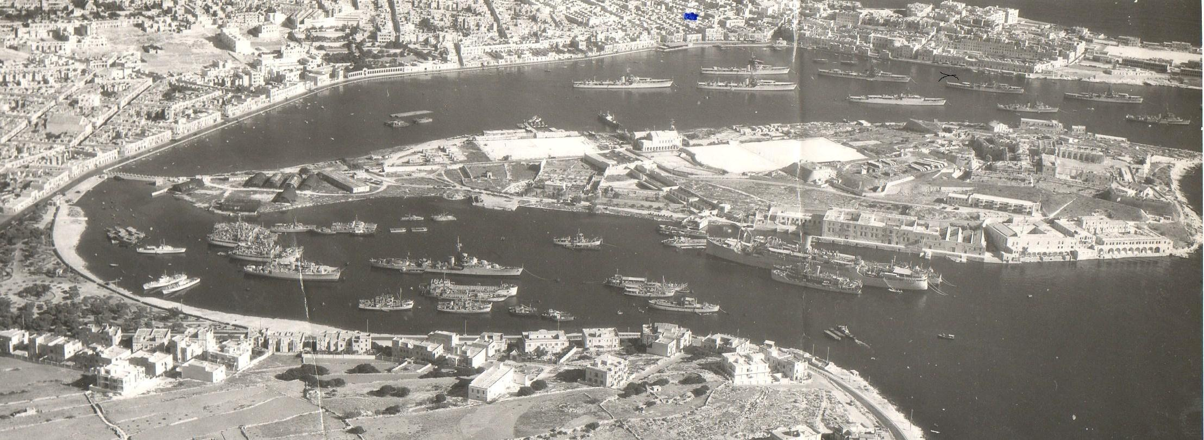
Sliema creek at the top of the picture.
We were taken by lorry through Valletta and around the coastline to the waterfront at Sliema where there were lots of Frigates and Destroyers tied up to Buoys in the middle of the creek with ships boats plying between ships and shore there were lots of local boats called dyhso’s (which are boat taxies), most ships had their own local dyhso which would take people ashore or bring them from the shore to the ship thereby saving calling the ships motorboat away,
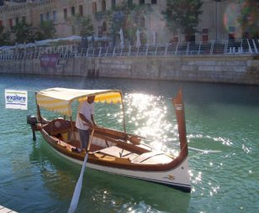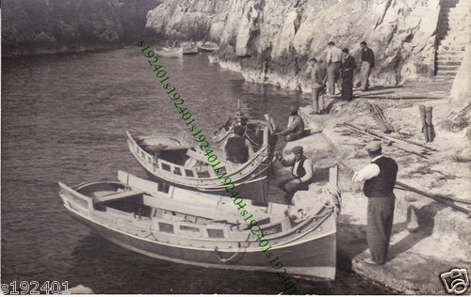
we were picked up by the ships boat and taken to the Mermaid. WE had all our kit with us, Kitbag, Hammock and little case. As we went over the gangway and saluted the quarterdeck the noise and bustle was overbearing the noise of the engines and all the fans and extractor fans giving off an eternal hum, the crew were storing ship with all manner of things while at the same time taking on water and fuel. We were shown to our messes clanking down steep steel ladders into the bowls of the ship, Bill and I were now separated, he going to the Boys mess and me as an Ordinary Telegraphist was shown to the Communications and Misc (Cooks, stores ratings etc) mess deck. I was allocated a box locker under the cushions of the seats that run the length of the mess deck. (About 18” x 18” by 18”) to stow my kit, then shown the location of the Hammock netting to stow my Hammock, I was also shown the two sky hooks that I was to be allocated to sling my “Mick”. Then I was introduced to the few members of the mess who were there, (Most of them were watch keepers and were ashore drinking or swimming or both) . after that, I was given a brief tour of the required facilities, e.g. Heads, washroom, galley, canteen and eventually taken to the B.W.O.( Bridge Wireless Office) where I would be spending most of my working days, it was a pokey little office, taken up on one side by a bench with Morse keys and old Underwood typewriter the same as in Ganges, above these were the radio receivers, type B28’ and 9‘s
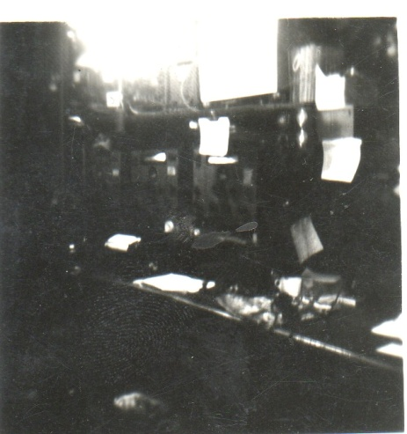

Valletta, Sliema Creek & Manoel

